Beyond Diffraction Limit: Sub-wavelength Imaging with STORM Abhik Bose 154033002 13.04.16
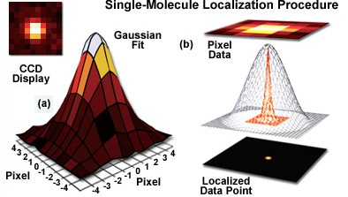
Optical microscopy is one of the oldest imaging technique known. In combination with fluorescence emission light microscopy has become most popular technique in biological field, sub-shell imaging etc. due it’s non-destructive nature and lest complex setup compared to electron microscopy and other alternate techniques. Despite enormous success in µm length scale light microscopy is fundamentally bounded with diffraction limited resolution of ~200nm which restricts it’s use in sub wavelength measurement. In last few decades diffraction limit is suppressed with development of different sub-wavelength imaging techniques. Based on methodology this super resolution techniques are broadly categorised into two classes viz. “Deterministic super-resolution” super resolution techniques achieved with modified super optics e.g. Near field Scanning Optical Microscope (NSOM), Stimulated Emission Depletion (STED), saturated structured-illumination microscopy (SSIM) etc. and “Stochastic super-resolution” microscopy where super resolved image is re-constructed by combining stacks of diffraction limited image with intelligent computational techniques. A chromophore can be preciously localised into sub-diffraction accuracy by fitting it’s point spread function (PSI) into Gaussian and locating the pick position, provided only one chromophore is present in the diffraction limited spot. By this the localization accuracy of a particular chromophore is limited by number of photon detected and hence standard deviation and not by diffraction limit anymore. Images are collected with small interval over a period of time where methodology is applied to stochastically switch on and off between emitters which eventually results precise localization of a small fraction of non-overlapping particle in each imaging cycle. The full image is re-constructed by combining all those preciously localized spots. Several reconstruction super resolution techniques are achieved based on their way of stochastic switching between emitters. Deterministic methods like NSOM require scanning of the sample and the field broaden quickly with increasing distance, whereas STED although provides high super-resolution accuracy but requires gigaWatt/cm² of laser power, so is not suitable for biological sample. In this review a Stochastic Optical Reconstruction Microscopy technique or STORM (discovered by Zuhang et. Al.²) is demonstrated to achieve sub-diffraction limited based on stochastic activation of a cyanine dye pair (Cy5-Cy3) requiring no sample scanning and high laser intensity for several molecules at a time.
Figure 1: Methods of localisation microscopy (a) Display in CCD and Point-Spread function (b) Fitting of PSI with Gaussian and localisation in sub wavelength resolution ¹
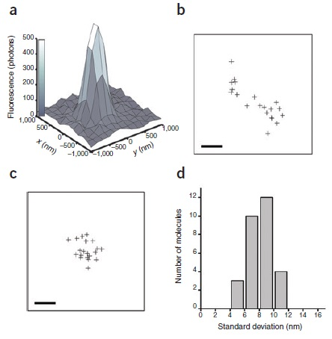
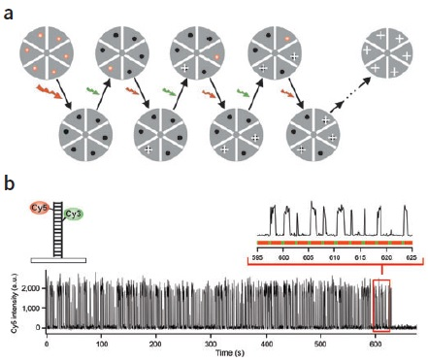
It’s shown that a cy5-Cy3 dye pair acts as a reversible optical switch between a fluorescent state and a non-fluorescent dark state in a Cy5-Cy3 distance dependence much sharper than FRET. An excitation with 633 nm or 647 nm red LASER light produces fluorescence from the Cy5 dye and simultaneously put the switch into a long living dark state (temporary photo bleached state) whereas irradiation to Cy3 with a 532 nm green LASER brings the switch back to a fluorescent state. To demonstrate STORM as a possible super resolution imaging technique the Cy5-Cy3 switch was contentiously irradiated with a red 633 nm or 647 nm LASER with a short pulse 532 nm green LASER periodically and image was recorded after each green pulse. In each imaging cycle a small fraction of the switches were stochastically activated by green pulse, localised, and then put into dark state by the red light. Super-resolution image was re constructed after fitting PSIs into Gaussian and locating them.
Figure2: STORM imaging with a hypothetical sample. (a) Stochastic activation, localization, temporary bleaching followed by reconstruction (b) Cy5-Cy3 pair, Emission intensity after alternating green pulse.²
To determine localisation accuracy a single Cy5-Cy3 dye pair, but in principle any photo switchable dye pair, with constant distance was constructed by binding them with a complimentary base pair of a small DNA chain fragment in an immobilised condition and was imaged in presence of alternating red and green laser light. PSI for each imaging cycle (Figure 3a) was fitted and located for each imaging cycle and all peak positions were combined (Figure 3b). Correcting the positions for stage drift (Figure 3c) was achieved an average standard deviation of 8 nm (Figure 3d) for individual switches and a FWHM of 18 nm was achived correspondingly. Therefore in this imaging condition two switches separated by 20 nm in lateral plane is resolvable.
Figure 3: Localisation accuracy of 20 nm with STORM imaging²
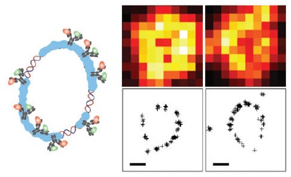
To demonstrate STORM imaging of a biological sample in 2 dimensions a RecA coated circular plasmid DNA was double immuno labelled with secondary antibody containing optical switch was immobilised over a glass surface with biotin-avidin chemistry and was imaged with STORM (Figure 4). Right top panel showing the diffraction limited imaged and bottom panel is the re constructed image. From standard distance of 46 nm between DNA base pair STORM imaging can clearly claim to resolve two chromophore separated by ~40 nm.
Figure 4: STORM Imaging of RecA coated plasmid DNA²
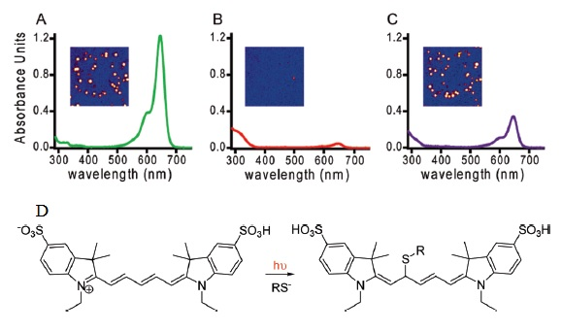
To explore the photoswitable nature and the so called dark state Cy5 (this experiment was not about cy5-cy3 switch, rather only Cy5 molecule) was irradiated with 647 nm red laser to a complete dark state and was observed in absence of any 532 nm green laser. Only ~10% of the dark molecule was observed to come back in fluorescent state even after one hour wait time, which indicates a half-life in the order of hour for the dark state whereas reported value of triplet state life time of cycnine dyes are in the order of millisecond, so it’s very less probable that this dark state is a triplet state. Other possibilities are charge transferred complex or some ionic species may be solvent bound in excited state. Presence of primary thiol is essential for this photoswitching behaviour. From Mass spectral fragmentation peak corresponding to the deprotonated solvent confirms binding of solvent molecule in dark state. Absorption spectra of the dark Cy5 molecule (Figure 4) lacks any 650 nm absorption band as compared to on state rather shows a new peak at around 310 nm UV irradiation at which region was found to bring the dark molecules back. The loss of activity may be due to permanent photobleaching due to UV irradiation. From this point it’s expected that the Cy5-solvent complex is broken by the UV radiation to bring the active state back. In case of Cy5-Cy3 switch⁴, as emission spectra of Cy3 overlap with the absorption of Cy5, on irradiation with 532 nm energy transfer from excited Cy3 to dark Cy5 by excited state dipole coupling is possible, but the exact nature of this coupling and distance dependence sharper than FRET is still not very well known. Latter many other STORM dyes were commercialised. Single dye molecule having coupled functional part from two different dye is also commercialised. A list of 26 commertially available dye and there comparison is available at ref ().
Figure 4: Absorption spectra of Cy5 (A) fresh (B) After 647 nm laser irradiation, dark state (C) 310 nm UV irradiated reactivated state. (D) Solvent binding in excited state³
Further in conjugation with cylindrical lenses induced astigmatism STORM study is extended into super resolved imaging in all 3 dimensions⁶. Although sample specific storm dye lakes it to be generalised for all kind of microscopy study, STORM is one of the most useful super-resolution technique for biological and live cell imaging.
References:
- http://zeiss-campus.magnet.fsu.edu/articles/superresolution/introduction.html Accessed On: 13.04.2016 10:10 pm IST
- Rust, M. J.; Bates, M.; Zhuang, X. Nat. Methods 2006, 3, 793.\
- Dempsey, G. T.; Bates, M.; Kowtoniuk, W. E.; Liu, D. R.; Tsien, R. Y.; Chem. Soc. 2009, 131, 18192–18193.
- Bates, M.; Blosser, T.R.; Zhuang, X. Phys. Rev. Lett. 2005, 94, 108101
- Dempsey, G. T.; Vaughan, J. C.; Chen, K. H.; Bates, M.; Zhuang, X. Nat. Methods 2011, 8, 1027–1036.
- Huang, B.; Jones, S. A.; Brandenburg, B.; Zhuang, X. Nat. Methods 2008, 5, 1047–1052.

